
HARVEST MISSION –
SEE SOMETHING, START SOMETHING WORKSHOP
November 4 – 8, 2025

Introduction
You are about to spend four days exploring the creative and human sides of leadership — how we see problems, how we learn, and how we act. This isn’t a week of lectures. It’s a week of experiments, conversations, and discoveries.
Each day builds on the one before it:
- Tuesday: Connection Before Content — You’ll start by building trust and curiosity. Before we solve problems, we connect as people.
- Wednesday: Creative Problem Solving (Simplexity) — You’ll learn a proven process for turning challenges into opportunities — and experience how changing how you see a problem changes the problem you see.
- Thursday: Lifelong Learning for Impact — You’ll explore what it means to stay adaptable, curious, and resilient in a fast-changing world.
- Friday: Leadership — See Something, Start Something — You’ll bring it all together, crafting your own small, courageous leadership starts — and even using AI as a creative sparring partner.
By the end of this week, you won’t just understand creativity, learning, and leadership — you’ll have practiced them. Every exercise is designed to help you see something new and start something real — in yourself, in your work, and in your community.
Along the way, you’ll capture Things to Start — simple actions or habits you want to carry forward. On Saturday, you’ll look back on those things you want to start, and the mindsets that mattered most and share with others in the organization.

This Week’s Agenda
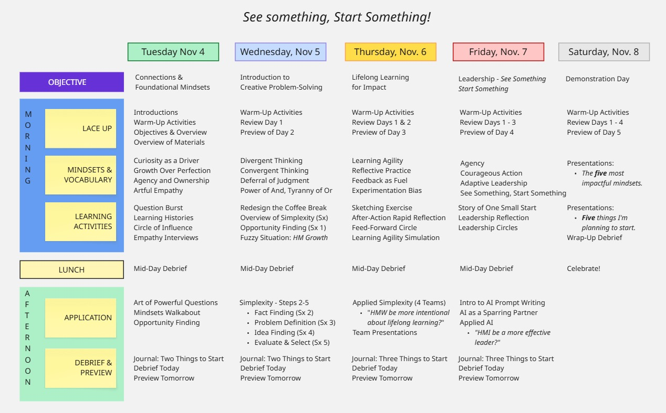

Using This Workbook After the Workshop

How to Keep the Material Alive
This workbook isn’t meant to sit on a shelf — it’s a field guide for growth.
Each page captures ideas, tools, and reflections that you can return to again and again.
Here’s how to keep it working for you long after we close our time together in Addis.

1. Revisit, Don’t Archive
Set aside ten minutes once a week to reread a section or two.
Look at the questions you asked, the sketches you drew, or the “Things to Start” you listed.
Ask yourself: What’s still true? What’s changed? What deserves a fresh start?

2. Practice the Mindsets Daily
The four mindsets for each day aren’t theory — they’re habits. Pick one each week to practice deliberately.
- When you notice judgment, pause and practice curiosity.
- When you feel stuck, ask a better question.
- When you see a gap, take ownership.
Mindsets are like muscles — they strengthen only when used.

3. Turn Activities into Tools
Every activity has a purpose beyond the workshop:
- Use Question Burst to open your next team meeting.
- Try After-Action Reflection after finishing a project.
- Apply Simplexity when a challenge feels fuzzy or overwhelming.
- Revisit the 4-C Prompt Builder when you want AI to help you think, not just answer.
Keep these methods visible — a quick reference before your next conversation, planning session, or creative sprint.

4. Track Your Starts
You recorded your Things to Start and “Why” each day.
Pick one or two and move them into your 30-Day Challenge page.
Small, steady progress beats ambitious plans that fade.
Share your starts with a colleague or accountability partner — energy shared is energy sustained.

5. Keep Learning Out Loud
Leadership grows when shared.
Talk about what you’re learning.
Ask for feedback.
Teach one of these tools to someone else.
Explaining a concept is the fastest way to master it yourself.

6. Reflect, Celebrate, Repeat
Reflection is the bridge between experience and improvement.
At the end of 30 days, pause and ask:
- What did I start that’s working?
- What needs another small experiment?
- Who noticed a difference?
Celebrate your progress — even if it’s imperfect. Then start again.
Growth doesn’t happen in a week; it begins in one.
Keep starting, keep reflecting, and keep turning learning into leadership.

Day 1 — Connection Before Content

Lace Up
- Tagline: Curiosity, Growth, and Empathy in Action
- Objective: You will build connection and trust as the foundation for creative problem solving.

Learning Activities
- Fun with Improv — “The Odd Things Challenge”
You’ll use random household items to create a story and solve a playful problem. This activity breaks down barriers, builds psychological safety, and demonstrates that creative thinking thrives under shared laughter and loosened expectations.
- Question Burst
You’ll practice asking only questions for a set time around a given problem. This builds curiosity and suspends judgment, teaching you how to unlock fresh insights through inquiry.
- Learning Histories
Together, you’ll revisit a past “failure” and reframe it as a valuable learning moment. This helps dismantle fear of mistakes and reinforces the Growth Over Perfection mindset.
- Circle of Influence
You’ll map what you can control, influence, and accept. This clarifies where to focus energy and how to take ownership even when conditions are uncertain.
- Empathy Interviews
You’ll practice deep listening — asking open questions and summarizing what you hear. This transforms empathy from an idea into a repeatable skill.

Application Activities
- The Art of Powerful Questions
Learn how to design questions that shift thinking. You’ll analyze sample questions and practice writing your own that begin with “How might we…?” to focus curiosity on opportunity, not blame.
- Mindset Walkabout — Observation in Motion
In pairs, you’ll walk the grounds asking only questions about what you notice. This teaches you to stay curious longer — a practical skill for problem discovery back at work.
- Opportunity Finding
You’ll revisit your notes and highlight where curiosity or empathy uncovered new possibilities. This practice turns everyday observations into creative opportunities for change.

Reflection & Journaling
- What did you notice about how you connect with others?
- What surprised you about the power of good questions?

My Things to Start — Day 1

Why: __________________________________

Why: __________________________________

Why: __________________________________

My Notes

Day 2 — Creative Problem Solving (Simplexity)

Lace Up
- Tagline: When you change how you see a problem, you change the problem you see.
- Objective: You will practice the rhythm of creative thinking — diverging, converging, and deferring judgment.

Learning Activities
- Divergent Thinking — The deliberate act of expanding possibilities. You separate idea generation from idea evaluation, generating as many ideas as possible without editing.
- Convergent Thinking — The complementary act of narrowing choices. You analyze, refine, and select the best ideas — using structure and criteria, not impulse.
- Deferral of Judgment — The conscious pause before critique. By postponing evaluation, you create a climate where people feel safe to share ideas.
- The Power of AND — A reminder to reject false trade-offs. Great innovation holds tension between opposites — speed and quality, creativity and structure, freedom and accountability.

Application Activities
- Simplexity Overview & Fuzzy Situation
You’ll explore the 8-step Simplexity process and practice on a real challenge — “How might we manage Harvest Mission’s growth?” This introduces structured creative problem solving that balances exploration and decision.
- Opportunity Finding
You’ll turn observations from Day 1 into How Might We statements — the bridge from empathy to innovation.
- Simplexity in Practice
Teams will work through the early stages of the process: Fact Finding → Problem Definition → Idea Finding → Evaluate & Select. You’ll learn how to move from fuzzy to focused using shared language and process.

Reflection & Journaling
- Which step of Simplexity stretched you the most?
- When did you notice judgment creeping in?

My Things to Start — Day 2

Why: __________________________________

Why: __________________________________

Why: __________________________________

My Notes

Day 3 — Lifelong Learning for Impact

Lace Up
- Tagline: The best leaders are the best learners.
- Objective: You will develop habits of reflection, feedback, and experimentation that make growth continuous.

Mindsets
- Learning Agility — The capacity to adapt quickly to new situations. Agile learners try, reflect, and adjust faster than conditions change.
- Reflective Practice — Turning experience into insight through deliberate pause. Reflection creates awareness that drives improvement.
- Feedback as Fuel — Seeing feedback as useful data for growth rather than criticism. Effective leaders invite and apply feedback continuously.
- Experimentation Bias — Favoring small, safe-to-try experiments over theoretical debate. Progress happens faster when you act your way into learning.

Learning Activities
- Sketching Exercise — Visual Reflection
You’ll sketch your personal learning journey from the week. Drawing engages different parts of the brain and helps you see patterns in your growth.
- After-Action Rapid Reflection
You’ll use a simple What / So What / Now What framework to debrief a recent project or activity. This tool can be used in daily work to close every loop with learning.
- Feed-Forward Circle
You’ll share a personal goal and receive constructive “feed-forward” ideas from peers. It’s feedback flipped forward — energizing, not defensive.
- Learning Agility Simulation
In teams, you’ll tackle a quick challenge — then face new constraints midstream. The point isn’t winning; it’s noticing how you adapt and learn under change.

Application Activities
- Applied Simplexity Challenge
You’ll apply Simplexity to a real question: “How might we be more intentional about lifelong learning?” Teams will use structured steps to discover insights and create new ways Harvest Mission can strengthen its learning culture.
- Team Presentations & Debrief
Each group will share key takeaways and reflect on how reflection, feedback, and agility showed up during the process. These stories model how to carry learning habits forward at work.

Reflection & Journaling
- What helped you stay open when things changed?
- Where do you see opportunities to apply reflection and feedback?

My Things to Start — Day 3

Why: __________________________________

Why: __________________________________

Why: __________________________________

My Notes

Day 4 — Leadership: See Something, Start Something

Lace Up
- Tagline: Turning awareness into action.
- Objective: You will connect learning and leadership by identifying opportunities, taking initiative, and crafting your own small start.

Mindsets
- Agency & Ownership — Leadership starts with responsibility for what you can influence. You don’t wait for permission — you act with integrity where you stand.
- Courageous Action — The willingness to start before you have all the answers. Courageous leaders take small, thoughtful risks that move things forward.
- Adaptive Leadership — Effective leaders flex their approach based on context, leading sometimes from the front, sometimes from behind.
- See Something, Start Something — Leadership is noticing what needs to change — and beginning, even when it’s uncomfortable.

Learning Activities
- Story of One Small Start
You’ll share a story about a time you took initiative. Reflecting on small acts of leadership helps you see that impact begins with awareness and courage.
- Leadership Reflection Exercise
Through guided writing and dialogue, you’ll identify one opportunity in your current work or life where you can lead more intentionally.
- Leadership Circles
In small groups, you’ll surface “moments that need leadership” within Harvest Mission — the gaps between what is and what could be.

Application Activities
- AI Prompt Writing Workshop — “How Might I Be a More Effective Leader?”
You’ll learn and apply the 4-C Framework (Context, Challenge, Constraints, Command) to use AI as a reflective partner for leadership development. This helps you generate insights, experiments, and feedback loops to sustain growth.
- Integration & Start Something Statements
You’ll turn your insights into visible commitments — crafting Start Something Statements that articulate what you’ll begin, how, and why. These are your seeds for post-workshop action.

Reflection & Journaling
- What insight about leadership surprised you today?
- What is one ‘small start’ you will take?

My Things to Start — Day 4

Why: __________________________________

Why: __________________________________

Why: __________________________________

My Notes

🌾 Harvesting What We’ve Started

Saturday Presentation Prep
This page helps you prepare for your Saturday report-out session. Review your “Things to Start” from each day and identify your top insights and mindsets.

My Five Things to Start (and Why They Matter)
1.
2.
3.
4.
5.

My Five Most Impactful Mindsets
1.
2.
3.
4.
5.

Notes for My Presentation
- Key takeaway I want to share:
- What I’ve learned about myself:
- How I’ll keep this alive after the workshop:

Appendix: Prompt Writing- Using AI as a Sparring Partner

Purpose
You will learn how to use AI as a reflection and coaching partner — not as a search engine. The better you ask, the better it helps.

Mindsets for Prompt Writing
Helpful Mindset | Description
Curiosity Over Certainty | Approach AI with open questions, not fixed answers.
Clarity Over Complexity | Be clear and simple. State your intent.
Iteration Over Perfection | Prompts evolve — refine as you go.
Partnership Over Transaction | Treat AI as a thinking partner, not a vending machine.

The 4-C Framework
Step | Ask Yourself | Example
Context | Who am I / what’s the situation? | “I lead a small nonprofit team focused on outreach.”
Challenge | What am I exploring or trying to solve? | “Help me motivate volunteers who are burning out.”
Constraints | What limits or tone matter? | “Keep suggestions practical and encouraging.”
Command | What do I want AI to do first? | “Give me three low-cost ideas to re-energize volunteers.”

Iteration Prompts
Use these to refine your conversation:
- “Ask me three clarifying questions.”
- “Rewrite that as a short action plan.”
- “Offer alternative perspectives.”
- “Turn that into something I could test this week.”
- “Ask me questions about ___ as if I were a fifth grader.”

Sample Leadership Prompts
Focus | Example Prompt
Self-Awareness | “I sometimes avoid conflict. Ask me questions to help me prepare for a feedback conversation.”
Decision Making | “List pros and cons of two leadership options I’m considering. End with one experiment to try.”
Coaching Others | “Help me design five open questions to coach a teammate struggling with motivation.”
Vision & Strategy | “Act as a facilitator. Help me craft a one-sentence vision that connects our daily work to long-term impact.”

4-C Builder Template
C | Ask Yourself | Write Here
Context | Who am I / what’s the situation?
Challenge | What do I want to explore or solve?
Constraints | What limits or tone matter?
Command | What do I want AI to do first?

How to Use AI to Write a Prompt When You’re Uncertain
AI can be a powerful thinking partner when you’re unsure how to start. When you face a question that feels fuzzy, stuck, or unfinished, use AI to help you clarify your thinking — not make decisions for you. Treat it like a skilled colleague who asks good questions and helps you see blind spots.
Start by describing what you’re wrestling with in everyday language. Then, give AI enough context to understand your situation and ask it to help you move forward. The clearer you are about what you don’t know, the more useful the AI becomes.

Example Prompt
“I’m uncertain about how to motivate my team right now. Morale feels low, and I’m not sure what’s causing it. It might be poor communication. Help me explore possible reasons for low motivation, then suggest three questions I could ask my team to understand their needs better.”
AI won’t give you the answer — it will give you better questions and next steps. Use those insights as a springboard for your own reflection, decisions, and experiments. When you’re uncertain, don’t wait for clarity — start the conversation with AI and let clarity emerge through dialogue (or sparring).

What Makes a Bad Prompt
AI can only work with what you give it — and unclear prompts lead to vague, shallow, or generic answers.

Common Bad Prompt Mistakes
- Too vague: “Tell me about leadership.” → This is too broad; the AI has no focus.
- No context: “How do I motivate people?” → Without background, AI can’t tailor its response to your situation.
- No direction: “Write something about teamwork.” → Without a goal or format, the AI doesn’t know what you want.
- Asking for perfection: “Give me the perfect solution.” → AI is best for iteration, not instant precision.
- No follow-up: Stopping after the first answer instead of refining the conversation.

Better approach
Add specifics, describe your role or challenge, and tell AI what kind of help you need.
Example Fix
❌ “Tell me about leadership.”
✅ “I lead a nonprofit team that’s struggling with communication. You are to serve as an expert communications consultant. To help me explore possible solutions to improve communication. I want you to ask me three provocative questions to help me consider our circumstances and start my imagination, then give me three suggestions to improve trust and collaboration within my group.”

Prompt Refinement Checklist
Good prompting is less about clever wording and more about intentional clarity.
When your AI response feels off, don’t start over — refine it.
Use this checklist to improve the quality of your thinking and your prompt.

1. Clarify the Role
Tell the AI who it is in this conversation. This shapes tone, depth, and focus.
“You are to serve as an expert communications consultant…”

2. Give Clear Context
Briefly describe your situation or goal. Include what you know, what you’re wrestling with, or what’s uncertain.
“I lead a nonprofit team that’s struggling with communication.”

3. Specify the Task
Tell the AI what kind of help you want — ideas, questions, a summary, or a framework.
“Ask me three provocative questions and then give me three suggestions…”

4. Add Constraints or Tone
Name boundaries or preferences: short answers, creative tone, practical focus, etc.
“Keep suggestions simple, realistic, and relevant to small organizations.”

5. Invite Dialogue
End by asking AI to engage with you, not deliver a final verdict.
“Ask me three questions to help me think this through.”

6. Iterate and Build
If the response isn’t what you expected, guide it:
- “Rephrase that in simpler language.”
- “Give me three alternative viewpoints.”
- “Turn that list into a one-week plan.”

7. Switch Languages for Clarity
Seeing a phrase in a different language might sometimes be helpful. Use the AI to translate a prompt for you to help you see it differently. You can, cautiously, mix different languages.
“Translate ‘give me three alternative viewpoints’ to Amharic” -> ሶስት ተለያዩ አስተያየቶች ስጠኝ።
“The name of my ውሻ is Chloe.”

Thank You for Being Part of This Week!
You’ve just spent the week practicing curiosity, creativity, learning, and leadership.
You’ve listened, questioned, experimented, and started small things that matter.
Remember — leadership isn’t a title or a moment. It’s a posture of seeing what needs to be done and starting something that makes it better.
- Keep asking artful questions.
- Keep building upon ideas.
- Keep learning out loud.
- And keep starting things.

“Never doubt that a small group of thoughtful, committed people can change the world. Indeed, it’s the only thing that ever has.”
— Margaret Mead

Facilitated by: Ron Brumbarger
Harvest Mission | See Something, Start Something | Addis Ababa, November 4–8, 2025

